title of paper (Uppercase, bold)
< Empty line >
Authors’ names should be written as:

First name(s) FAMILY NAME¹, Second Author², …without academic titles
¹name of institution, city and country, ²name of institution, city and country (if different)
E-mail: < Only the corresponding author’s e-mail address >
< Empty line >
< Empty line >
Summary: < The summary should be at least 50 words and no more than 250 words long. The summary should explain the purpose of the research, the methodology, the principal findings, the main points of discussion, and the conclusions. Do not skip a line between summary’s paragraphs. Use 12 pt Times New Roman. Justified text>
< Empty line >
Keywords: < minimum 3, but maximum 5 keywords >
< Empty line >
< Empty line >
1. Main (first level) section titles
< Empty line >
First-level headings should be left-aligned, written in bold, using lowercase letters, with two empty lines before and one empty line after the heading.

Your manuscript should be written in English on A4 (210x297mm) paper, using single spacing. Skip a line between paragraphs.

Use 2.5 cm margins on all four sides of the paper. The manuscript must be submitted as a Microsoft Word document. Font: Times New Roman 12 pt.

Please do not insert page numbers!

Use justified text with no paragraph indentation. Do not hyphenate words at line breaks. The paper should be between 30,000-40,000 characters in length (approximately 10-15, but maximum 20 pages).

The manuscript may contain up to three levels of headings. The first level (1.) is flush with the left margin, lowercase letters, bold, two blank lines before and one line after.

The second level (1.1) is left-aligned, lowercase letters, bold and italic, one blank line before and one line after.

The third level (1.1.1) is left-aligned, lowercase letters, italic, one blank line before and one line after. (See title examples below.)
< Empty line >
1.1 Subsection (second level) titles (left-aligned, lowercase letters, bold and italic, one blank line before and one line after)
< Empty line >
Tables and figures should be numbered consecutively (1, 2, 3, etc.), single spaced. Figures and tables must be print-ready and inserted in the text.
Titles of tables and figures should be in Times New Roman 11 pt, bold, centered, 1 blank line before and after the title and 1 blank line after the source.
Text of tables should be in Times New Roman 11 pt. Leave the 2.5 cm margin on both the left and right sides of the page.
All tables and figures must be clear and visible. Figures (diagrams) should be submitted in JPG or PNG format and be of high quality.
Sources should be in Times New Roman, 11 pt.
< Empty line >
Table 1: Title of table one with format (11 pt, bold, centered)
< Empty line >
Column 1 | Column 2 | Column titles with 11 pt, bold, centered
11 pt words | 11 pt numbers
Source: own calculations or own compilation based on (Author, year)
< Empty line >
1.1.1 Subsection (third level) titles (lowercase, italic, left, 1 blank line before and 1 line after)
< Empty line >
Formulas and equations: Times New Roman 12 pt, centered, variables in italics.
All units of measurement should be metric.
Photographs should be kept to a minimum, but where relevant, should be clean, sharp images.
Figure example:
< Empty line >
Figure 1: Porter’s Industry Analysis Model
< Empty line >
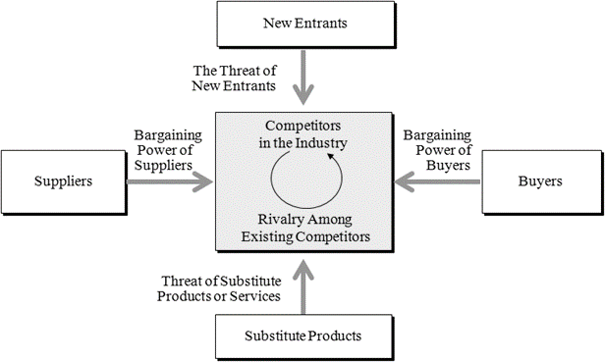
Source: Porter (2006), p. 30.
< Empty line >
Footnotes should be used only when necessary. Font size: 10 pt.
< Empty line >
< Empty line >
References (Without title numbering, left, bold, 2 blank lines before and 1 line after)
< Empty line >
References should follow the Harvard referencing style, with in-text citations. Please do not use footnotes for citation.
List all references in alphabetical order at the end of the paper. Each entry in the reference list should include the following:
Books: Author surname, initial. (Year): Book title. Publisher, City.
Book / Monograph / Proceedings chapter: Author surname, initial. (Year): Chapter title, in Editor surname, initial. (ed./eds.) Book title. Publisher, City. pp. page range
Journals / periodicals: Author surname, initial. (Year): Article title, Journal Name, Volume(Issue), pp. page range. doi:DOI.
Website: Author surname, initial. (Year): Page Title. Available at: URL (Accessed: Day Month Year).
Please include the DOI where available, but do not format it as a hyperlink.
Do not number the reference items. See examples below:

Bullinger, H. J. & Warnecke, H. J. (eds.) (1985): Toward the factory of the future, Springer-Verlag, Berlin.
Holt, D. H. (1997): Management principles and practices, Prentice Hall, New York.
Lee, T. W.; Ashford, S. J.; Walsh, J. P. & Mowday, R. T. (1992): Commitment Propensity, Organizational Commitment, and Voluntary Turnover: A Longitudinal Study of Organizational Entry Processes, Journal of Management, 18(1), 15-32. doi 10.1177/014920639201800102
McCarthy, E. J.; William, D. P. & Pascale, G. Q. (1997): Basic marketing, Irwin, Sydney.
Nagy, T. Z.; Hurta, H.; Dunay, A. & Illés, B. Cs. (2015): The comparison of the organizational culture of an Austrian and a Hungarian chemical engineering company. In: Proceedings of the 5th International Conference on Management 2015. Management, leadership and strategy for SMEs' competitiveness. Szent István University Publishing House, Gödöllő, pp. 35-39. doi: 10.17626/dBEM.ICoM.P00.2015.p007
Skowron-Grabowska, B. (2017): Knowledge management in innovative and social processes of enterprises. In: Illés, B.Cs, Nowicka-Skowron M., Horska, E., Dunay, A. (Eds.) Management and Organization: Concepts, Tools and Applications, Pearson, Harlow. pp. 191–200. doi:10.18515/dbem.m2017.n02.ch16
The British Psychological Society (2018): Code of ethics and conduct. Available at: https://www.bps.org.uk/news-and-policy/bps-code-ethics-and-conduct (Accessed: 22 March 2022).

